Classifying Gait Behavior in Children and Adolescents: A Multiple Regression Approach Using Cadence to Predict the Walk-to-Run Transition

Scott W. Ducharme1, Dusty S. Turner2, James D. Pleuss2, Aston K. McCullough1, Christopher C. Moore1, John M. Schuna Jr3, Diana M. Thomas2, Catrine Tudor-Locke1*, & Elroy J. Aguiar1

*1Physical Activity & Health Laboratory, Department of Kinesiology, University of Massachusetts-Amherst, Amherst, Massachusetts*

*2Department of Mathematical Sciences, United States Military Academy-West Point, West Point, New York*

*3School of Biological and Population Health Sciences, Oregon State University,*

*Corvallis, Oregon*

**\*Corresponding author:**

Catrine Tudor-Locke, PhD, FNAK, FACSM

Department of Kinesiology

University of Massachusetts Amherst

160A Totman Building

30 Eastman Lane

Amherst, MA, 01003

Phone: +1 413 545 1583

Email: [ctudorlocke@umass.edu](mailto:ctudorlocke@umass.edu)

Keywords: preferred transition speed, step frequency, locomotion, physical activity,

# Abstract

**Background:**

**Purpose:**

**Methods:**

**Results:**

**Conclusions:**

**Keywords:**

# Introduction

During upright locomotion, individuals generally choose to walk at relatively slow speeds (i.e., < 1.6 m/s) and run at faster speeds (i.e., > 1.6 m/s) (ref). When an individual progressively increases their locomotor speeds, the transition from walking to running appears spontaneous. Numerous studies have attempted to explain this preferred transition speed (PTS) phenomenon. For example, the transition to running may occur because, compared to running at a given speed, fast walking at that same speed correlates to reduced stability (Diedrich & Warren, 1995), greater metabolic cost of walking (Diedrich & Warren, 1995), greater perceived effort (Noble et al., 1973), or suboptimal energy substrate use (Ganley, Stock, Herman, Santello, & Willis, 2011). Mathematically, the Froude number (i.e., Fr = v2/(g*l), where v = velocity, g = acceleration due to gravity, and l = leg length)), which models gait as an inverted pendulum and thus incorporates leg length, suggests that this transition occurs when the centrifugal acceleration forces exceeds the centripetal forces due to gravity, thereby requiring a flight phase (Alexander, 1989; Usherwood, 2005).

Irrespective of the mechanism, determining the threshold for this transition is important because it would allow for a more precise classification of gait behavior. Wearable sensors are becoming increasingly popular in laboratory and free-living research, as well as personal use by consumers. Many sensors provide minute-by-minute step data (i.e., cadence [steps/minute]). Whereas determining the PTS requires precise speed information, which is not available in most wearable sensors, cadence may provide a more accessible measure of gait behavior, i.e., walking versus running. Thus, the preferred transition cadence (PTC) may be a better outcome measure for researchers or clinicians aiming to quantify physical activity behavior (specifically, minutes per day running).

Diedrich & Warren (1995) reported the PTC was, on average, at 142.8 steps/minute in young, healthy adults. A more recent study provided concurring evidence that the walk-to-run transition can be accurately predicted using a stride frequency of 70.8, i.e., 141.6 steps/minute (Hansen, Kristensen, Nielsen, Voigt, & Madeleine, 2017). However, while a PTC has been determined in adults, it remains unclear what this transition frequency is across the developmental lifespan of 6-20 years. Moreover, in the study by Hansen et al., leg length did not affect the observed PTC in 26 young adults. In younger individuals, the range of heights and leg lengths is much larger than in adult populations. Thus, accurate prediction of the PTC may necessitate precise measures of leg length (or height), as well as other anthropometric values such as mass. Therefore, the purpose of this study was to develop a model to predict age- and anthropometry-specific PTCs in individuals 6-20 years old. We hypothesized that the combination of cadence and leg length would provide sufficient information to accurately classify gait behavior.

# Methods

## Study design and regulatory information

This is a secondary analysis of data from the CADENCE-Kids study (Clinical Trials.gov - NCT01989104). A full description of the study design and participant characteristics are reported in Tudor-Locke et al. (2018).

## Participants

One hundred twenty-three children and adolescents aged 6 to 20 years volunteered to participate. For participants 6-17 years of age, informed parental/legal guardian permission and child assent was required. All participants aged 18-20 years provided informed consent. Because of the considerable changes to leg length throughout childhood and adolescence, and to ensure a uniform age distribution, study enrollment was set up such that at least 4 boys and 4 girls from each age year would be included. All participants were able to ambulate without an external device, free from mental illness within the past 5 years, not pregnant, and not taking any medication that affects heart rate’s response to exercise.

## Anthropometric Measures

Barefoot standing height was measured via a stadiometer (Harpenden; Holtain Ltd., Crosswell, Crymych, Pembrokeshire, UK). Seated height was also measured with the stadiometer, whereby participants sat on a table with legs freely hanging. Leg length was quantified as standing height minus seated height. Height and weight measurement precision was to the nearest 0.1 cm. Mass was measured using a Tanita digital scale (Tanita SC-240; Tanita corporation, Tokyo, Japan). All measurements were performed twice. If the height or weight measurements differed by > 0.5 cm or 0.5 kg, respectively, a third measurement was taken, and the average of the closest two measurements were used.

**Cadence Measures**

Cadence (steps/minute) was determined via direct observation (hand tally) of accumulated steps during each 5-minute trial divided by 5. A video recording (GoPro Hero 3) of each participant’s lower body provided a redundant record for step verification purposes in the event of miscounting or ambiguous data.

## Protocols

Participants fasted for at least 4 hours prior to data collection (necessary for metabolic data not presented herein). Participants performed sequentially faster treadmill walking trials, starting at 13.4 m/minute (i.e., 0.5 mph) and increasing in 13.4 m/min increments until: 1) completion of the fastest speed (134.0 m/min; 5.0 mph) for the protocol 2) completion of the trial during which participants freely chose to run, or 3) researcher or participant volition.

## Data and Statistical Analysis

Of the 123 potential participants, 69 performed a running trial. Thus, only these data were used for model development.

**Model Development**

Regression models were developed using a set of independent variables after linear dependencies were removed. The dependent variable for all models was the participant walk to run transition cadence. The best subsets method of identifying the optimal model was applied using the “leaps” package in **R** (**R** Core Team 2012). The leaps algorithm was used to compare regression models for every possible subset of factors, selecting the model with the lowest Bayesian information criterion (BIC). A k-means clustering approach feeding a Gaussian mixture model and regularization methods were also considered.

**R Shiny App Development**

An R Shiny application was created in R (R Core Team 2012) to provide users with the expected pace at which a participant will transition from walking to running, given their individual-specific parameters.

# Results

**Participant characteristics**

Participant demographic data are reported in Table 1. The 69 participants consisted of a mix of male (n=37) and female (n=32) individuals, all of which were treated identically in model development.

**Table 1:** Subject characteristics. Results are presented in mean ± SD.

|  |  |  |  |  |
| --- | --- | --- | --- | --- |
|  | N | Age | BMI | Walk-to-Run Transition Cadence |
| Males | 37 | 15.0 ± 3.88 | 22.6 ± 6.01 | 156 ± 10.2 |
| Females | 32 | 14.9 ± 3.70 | 21.9 ± 4.66 | 158 ± 8.92 |

The list of independent variables considered for model development are in Table 2. Two sets of highly correlated (greater than 90%) independent variables were identified; waist circumference strongly correlated with weight, while BMI percentile correlated with BMI z-score. Waist circumference and BMI percentile were removed from consideration because weight is an easier and more practical measure for an individual to attain and because BMI z-score is a more rigorous representation of a person’s BMI by accounting for age and gender.

**Table 2:** List of independent variables used to develop models.

|  |  |
| --- | --- |
| **Independent Variable** | **Explanation** |
| Sex | Male or Female |
| Age (years) | Age of participant |
| Height (cm) | Height of participant |
| Weight (kg) | Body weight |
| Waist (cm) | Waist circumference |
| BMI (kg/m2) | Body Mass Index |
| BMI percentile | The percentile of the participant’s BMI |
| BMI z-score | The standardized BMI score for the participant based on age and gender |
| Classification of Obesity Status | 85th percentile BMI designated overweight, 95th percentile BMI designated as having obesity |
| % body fat | Measured using bioelectrical impedance |
| Walk VO2 | Oxygen uptake in mL/kg/min during walking phase. |
| Run VO2 | Oxygen uptake in L/min during running phase. |
| Run METS Youth1 |  |
| Run METS Youth 3 |  |
| Walk METS Youth 3 |  |

**Mathematical Models**

After comparing regression models for every possible subset of factors, the leaps algorithm arrived at an optimal regression model:

$$\text{cadence}=255.29-1.16*\text{Age}-0.67*\text{Height}+0.50*\text{Weight}-5.68*\text{BMIz}$$

**Other Considered Models**

The k-means clustering approach feeding a Gaussian mixture model did not provide the predictive power of the regression model based on BIC. Regularization methods also did not outperform multiple linear regression.

**App Development**

Figure 1 depicts the user interface of the developed R Shiny app available at <https://dustyturner.shinyapps.io/KidsStep/>. After the user inputs age, gender, height, and weight, the application returns the expected walk-to-run transition cadence with a 95% prediction interval. The application also calculates an individual’s BMI and subsequent BMI z-score.

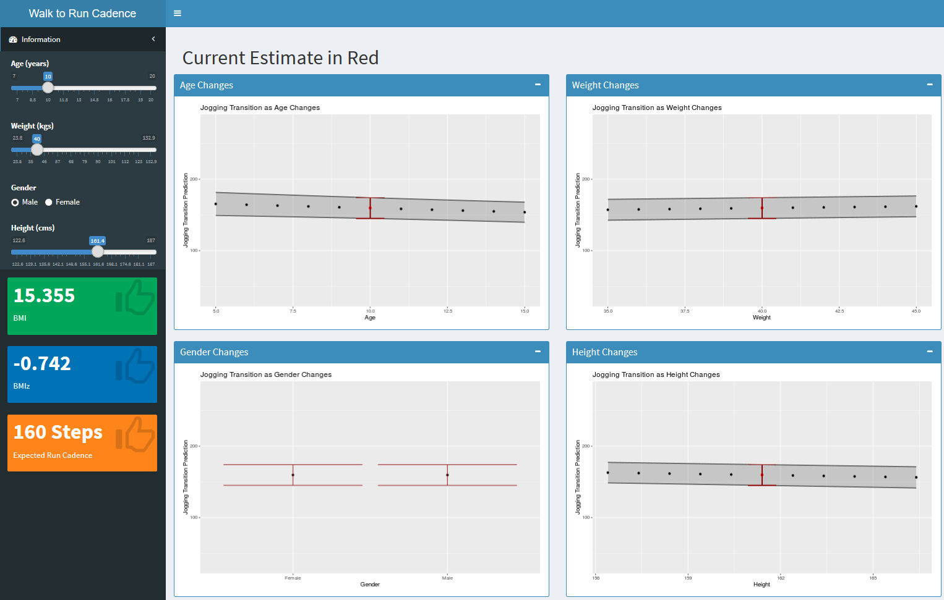

**Figure 1:** Screen shot of the R Shiny App. After user input, BMI (green) and BMI z-score (blue) are output with expected walk-to-run transition cadence (orange). The graphs on the right displays walk-to-run transition cadence and 95% prediction interval in response to changes in user inputs.

# Discussion

The purpose of this study was to develop a model to predict age- and anthropometry-specific PTCs in individuals 6-20 years old. We hypothesized that the combination of cadence and other anthropometric measures would provide sufficient information to accurately classify gait behavior. The results of the multiple regression analysis revealed a simple mathematical equation can be used to estimate the PTC from age, height, mass, and BMIz, within an accuracy of ± XX.X steps/minute. Moreover, the Shiny App herein provides researchers and clinicians with an easy tool to estimate the PTC for physical activity behavior assessment.

The independent variables selected for the final model were fortuitous with regards to application of this model to the general population. Three of the four variables used (age, weight, and height) are easily attained by any individual. The fourth variable, BMI z-score, can be calculated from the other three variables and the AGD package (Van Buuren, 2018) in R. This possibility for application to the general population was the impetus behind creation of the Shiny application.

Previous efforts to establish speed-based transition thresholds (i.e., previously mentioned PTS) have been reported in children. For example, one study evaluated the PTS in 11, 13, and 15-year-old adolescents, but did not report on the PTCs (Tseh, Bennett, Caputo, & Morgan, 2002). To our knowledge, the study presented herein is the first to use cadence to predict the walk-to-run transition in children, adolescents, and young adults. The findings that cadence, height, and mass provide sufficient evidence provide support for the notion that this transition occurs based on anthropometric or mechanical constraints. However, future research may also expand to include other measures such as rating of perceived exertion, metabolic cost, or XYZ.

**Conclusion**

Using standard demographic information (i.e., age, height, and mass), the cadence corresponding with the transition from walking to running can be accurately predicted. This information is highly beneficial for individuals attempting to characterize locomotor behavior in the free-living setting. Moreover, herein we provide a free, user-friendly app for use by researchers or clinicians to determine this threshold without the need to incorporate the equation.

# Acknowledgements

# Conflicts of Interest

**Tables**

# References

Alexander, R. M. (1989). Optimization and gaits in the locomotion of vertebrates. *Physiological Reviews, 69*(4), 1199-1227. doi:10.1152/physrev.1989.69.4.1199

Diedrich, F. J., & Warren, W. H. (1995). Why change gaits? Dynamics of the walk-run transition. *Journal of Experimental Psychology: Human Perception and Performance, 21*(1), 183-202.

Ganley, K. J., Stock, A., Herman, R. M., Santello, M., & Willis, W. T. (2011). Fuel oxidation at the walk-to-run-transition in humans. *Metabolism, 60*(5), 609-616. doi:10.1016/j.metabol.2010.06.007

Hansen, E. A., Kristensen, L. A. R., Nielsen, A. M., Voigt, M., & Madeleine, P. (2017). The role of stride frequency for walk-to-run transition in humans. *Sci Rep, 7*(1), 2010. doi:10.1038/s41598-017-01972-1

Noble, B. J., Metz, K. F., Pandolf, K. B., Bell, C. W., Cafarelli, E., & Sime, W. E. (1973). Perceived exertion during walking and running. II. *Med Sci Sports, 5*(2), 116-120.

Tseh, W., Bennett, J., Caputo, J. L., & Morgan, D. W. (2002). Comparison between preferred and energetically optimal transition speeds in adolescents. *European Journal of Applied Physiology, 88*(1-2), 117-121. doi:10.1007/s00421-002-0698-x

Tudor-Locke, C., Schuna, J. M., Jr., Han, H., Aguiar, E. J., Larrivee, S., Hsia, D. S., . . . Johnson, W. D. (2018). Cadence (steps/min) and intensity during ambulation in 6-20 year olds: The CADENCE-Kids study. *International Journal of Behavioural Nutrition and Physical Activity, 15*(20).

Usherwood, J. R. (2005). Why not walk faster? *Biology Letters, 1*(3), 338-341. doi:10.1098/rsbl.2005.0312

Van Buuren, S. (2018). _AGD: Analysis of growth data_ (Version 0.38). CRAN: The Comprehensive R Archive Network. Retrieved from <https://CRAN.R-project.org/package=AGD>